## Installing Node.js

1. Download the latest version of  Node.js Installer [here](https://nodejs.org/en/).
2. Run the installer.
3. Follow the installer steps, and click the next button. Finally, click the Install button to run the installer. When it finishes, click Finish.
4. Restart your system/machine.
5. At last, verify whether you have properly installed Node.js in your window, run the following command in “Command Prompt”:

type *node -v* command, the system should display the Node.js version installed on your system.

type *npm -v* command, the system should display the NPM version installed on your system.

## Installing JSON Server

1. Create a folder, for example: “d:\api-mocker”
2. Open “Node.js Command prompt”, and go to the folder by running command *cd /d D:\ api-mocker*
3. Run command *npm init* , it will take a while to process, press Enter for everything. Finally, enter ‘yes’ for last step. It will create package.json file in your folder. (You are creating a new project here)
4. Run command *npm install json-server* , this will install and add json-server as a package into your project
5. Next step is creating a database file. You create a <file-name>.json that stores the data of the mock database in JSON format. Let’s add some data to the file. For example, let’s name the file mockerDB.json.

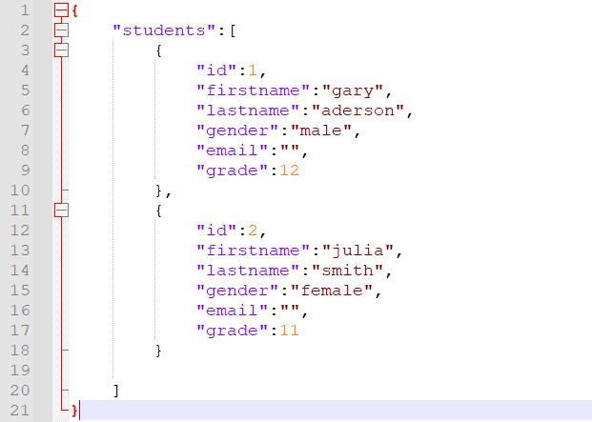

1. Open “package.json” file. In “scripts” key, add "start": "json-server --watch mockerDB.json"

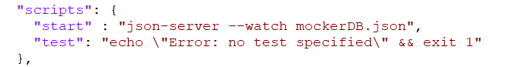

1. Run command *npm run start* -- for starting the server, and it will load data from mockerDB.json

When it finished, you should have the Mock REST API running at <http://localhost:3000>